Coupled and Single Term LNN Training Update
  - How the two models work and what the dissipative comparison shows
JunXi Wu
October 12 2026 at 19:03 Phoenix time

Present conclusion
Both generic Lagrangian neural networks are prepared for the full training process used by the executable Cranmer relativity notebook. The single-term model learns relativistic travel under known thrust. The coupled model learns one formula for travel, turning, cable stretching and rotor spin together. Their full training results are still pending. The early single-term model is inaccurate, and the five-update coupled profile is only a code check.
The coupled long run is authorized as a mathematical benchmark. Its unresolved high-speed clock and field conventions still prevent a claim that it describes a real relativistic spacecraft. The physical restriction remains in the training code; long mathematical runs require an explicit benchmark setting and a passed numerical audit.
Model or control | Current state
Original notebook control | 83,200 of 300,000 updates recorded; running
Single relativistic term | 1,000-update trial complete; five full seeds remain behind the source-control gate
Coupled mathematical model | Five-update profile checked; separate five-seed full queue launched and waiting for the source control and joint smoke
Physical coupled spacecraft claim | Gated pending clock, field and material audits

Which original training process is followed
The paper describes batch size 32. The actual SpecialRelativity notebook training loop uses batch size 512 and 300,000 updates. This study follows that executable notebook, pinned to commit 3b994720c87ebcb4b32a9bae5b09994567a79c2a. The difference is recorded instead of mixing the two recipes.
The existing source-control process continues unchanged. A second durable queue waits for its success checks, then runs the coupled benchmark. The queues have separate frozen code copies. They continue while the computer stays awake and their processes remain alive; they are not a remote computing service.

The single relativistic term explained
At low speed, kinetic energy is approximately one-half mass times speed squared. Near light speed, this approximation breaks down. The relativistic action contains a square root that accounts for how increasingly difficult it becomes to accelerate an already fast object. Adding a constant to the action does not change its equations, so we shift it to be zero at rest.
$$L = {\text{Mc}}^{2}(1 − \sqrt{1 − \frac{v^{2}}{c^{2}}})$$
M is the fixed spacecraft mass, v is its speed, and c is light speed. Define β = v/c and γ = 1/√(1 − β²). Differentiate L with respect to v to obtain momentum. Differentiating momentum once more gives the effective resistance to changing speed.
$$p = \frac{∂L}{∂v} = Mγv ; \frac{∂p}{∂v} = Mγ^{3}$$
The Euler–Lagrange rule says that the rate of change of momentum equals the known external force F. There is no position potential in this one-term action. The equation therefore becomes
$$Mγ^{3}\frac{\text{dv}}{\text{dt}} = F ; \frac{\text{dv}}{\text{dt}} = \frac{F}{M}{(1 − β²)}^{3/2}$$
The code uses q = ax/c² and s = at/c, with a = 15 m/s². Its force input is g = F/(Ma). The scaled equation is dβ/ds = g(1 − β²)³⁄². Known thrust is supplied to the mechanics calculation; it is not another learned Lagrangian term. Without a drive, all free-particle accelerations would be zero and those labels alone would not identify the relativistic law.

What the network has to learn
The network receives position and speed and returns one scalar, its proposed action. JAX differentiates that scalar twice to calculate the resistance to acceleration and solves the mechanics equation. Training adjusts the network until its calculated accelerations match independent analytical labels. The formula above is used to make the labels; it is not hard-coded into the learned network.
The notebook control uses its own toy action γ − 1 and acceleration g(1 − β²)⁵⁄²/(1 + 2β²). That target differs from the standard relativistic action derived here. The control preserves the notebook target; the spacecraft adaptation keeps the physical one-term target and reuses the training process.

What conservation means with an engine running
$$E = v\frac{∂L}{∂v} − L = {\text{Mc}}^{2}(γ − 1) ; \frac{\text{dE}}{\text{dt}} = Fv$$
An engine adds energy. A successful powered model must match the change in physical energy to the work done by the force. Keeping the network’s own invented energy constant would not establish that it learned the correct physical law. The evaluations report true and learned energy balances separately.

How the coupled model joins the moving parts
The coupled model has nine coordinates: three positions, three hub angles, two cable extensions and one rotor angle. Its network takes these coordinates and their nine rates, then returns a single scalar action. A change to an extension changes the rotor inertia; turning the hub changes field and tidal energies; rotor motion can exchange angular momentum with the finite hub. The calculation therefore contains cross-effects between the parts.

The internal motion
First place the hub, habitat and counterweight relative to their common center of mass. If ρ is one part’s position in the hub frame, its internal inertial velocity is the hub’s turning motion plus its motion relative to the hub. The symbol × means the vector cross product.
$$u_{j} = ω × ρ_{j} + {ρ̇}_{j}$$
$$T_{\text{internal}} = \frac{1}{2}ω^{T}I_{\text{hub}}ω + \frac{1}{2}∑ m_{j}{|uⱼ|}^{2}$$
The hub inertia is the inertia of the actual cylinder, rather than an infinitely heavy anchor. The point-mass velocities include changing cable lengths and rotor angle. Squaring their full velocities supplies the coupling terms automatically. Cable elastic energy is one-half stiffness times extension squared, summed over the two cables.

The environmental terms
The action adds the standard relativistic translation term and internal kinetic energy, then subtracts cable elastic energy. It adds stellar gravity terms GMm/r and subtracts outward radiation terms K/r. Electric and magnetic coupling uses charge times A·v − φ, plus the dipole term μ·B. Here A is the magnetic vector potential, φ the electric potential and μ the body’s magnetic dipole vector.
Gravity-gradient energy describes a star pulling slightly harder on one part of the body than another. Its expression uses the full centered inertia I, the unit star direction n in the hub frame and the distance d.
$$U_{\text{tidal}} = −\frac{1}{2}∑ \frac{{\text{GM}}_{j}}{{d_{j}}^{3}}(tr I − 3{n_{j}}^{T}I n_{j})$$
The action subtracts this tidal energy. Because the star direction changes with both location and attitude, differentiation produces both a turning effect and its corresponding position force. It is not enough to add an unrelated torque to a travel-only model.

Why the present interpretation is limited
The whole action uses a common coordinate time and one energy scale. Coordinate scaling is differentiated through the complete formula, so no subsystem receives an arbitrary energy multiplier. This gives a tested mathematical system. The internal clock and electromagnetic conventions at relativistic travel speed still need a consistent physical derivation. Successful fitting of this target would establish numerical learning of the chosen equations, not resolve that physics audit.

What the code and training do
physics.py generates independent state and force samples and their exact acceleration labels. The single-term labels use the analytical relativistic equation. The coupled labels use a preconditioned solve of the differentiated exact action. engine.py builds the network, computes derivatives and performs the generic Euler–Lagrange calculation. train.py measures the acceleration error, updates the weights and saves resumable checkpoints.
$$H = L_{v v} ; C = L_{v q} ; a = H^{+}(L_{q} + Q − Cv)$$
H is the matrix of second velocity derivatives, C contains the mixed derivatives, Q is the known external force, and H⁺ is its pseudoinverse. A nearly singular matrix can make the learned motion unreliable even when this expression returns a finite number. Rank, singular values and signs are therefore monitored.
Setting | Executed process
Network | Four hidden layers of 500 Softplus units; one scalar output; original custom initialization
Training budget | 300,000 updates per run; five main seeds numbered 0 through 4
Batch and memory | 512 logical samples; accumulated in chunks of 32 for one term and 16 for the coupled model
Loss | Absolute acceleration error weighted by 1 + γ; coupled errors divided by fixed reference component scales
Learning rate | Original cosine schedule from approximately 0.00065 through 0.001 to 0.0000001
Precision and Adam | Historical source uses float32 and fractional index; PHM adaptations use float64 and integer update index
Checkpoint selection | 10,000 fixed validation states with seed 1000; lowest validation error
Independent final test | 10,000 states with seed 2000, after full training; not used to select the checkpoint

Each batch produces one optimizer update, even when its gradients are calculated in smaller chunks. No extra energy loss, trajectory loss, speed clipping or Hessian regularizer is included. The generic network has to learn the kinetic structure itself. A structured model supplied with exact kinetic energy would be a separate experiment.
The new evaluator compares coupled motion on one-second and ten-second windows and attempts the mission duration with a fixed computation limit. It saves attitude, cable, spin, habitat acceleration and energy traces. Failed runs keep their accepted prefix, leave missing tails empty and remain in the failure count. A verified stiff or multirate mission solver and the interaction ablations are still outstanding.

Travel compared with the original dissipative system
The reference now uses the dissipative system in PHM_Derivations.pdf and its archived numerical parameter set, rather than the earlier drag strength 0.02. Its nominal travel model includes gravity, radiation, gas and dust drag, engine thrust and supplied changing mass. Electromagnetic fields and translational impacts are zero in that archived nominal case. The one-term network checkpoint still has only 1,000 updates.
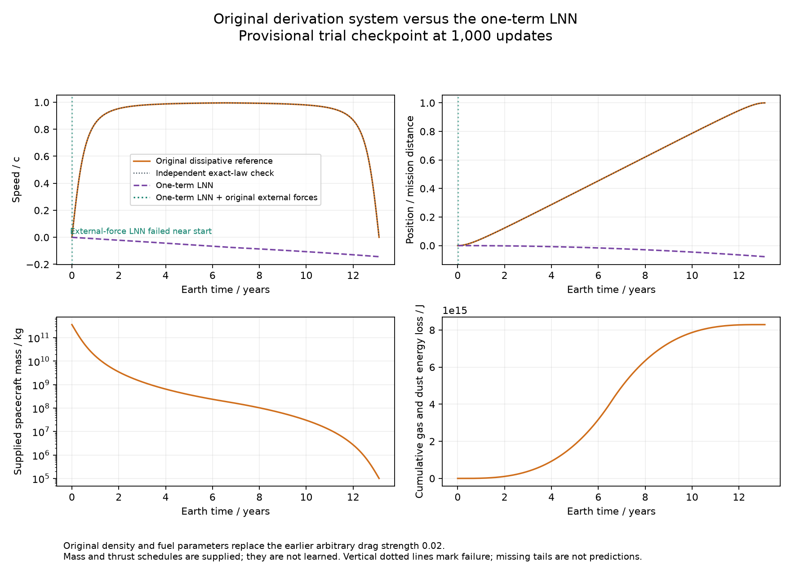
Figure 1 Original mission travel and the current one-term LNN. Orange is the archived dissipative reference; the dark dotted exact-law check almost coincides with it. Purple is the conservative LNN with the same acceleration and braking schedule. Green also supplies the original external forces. Its failed path ends near the start; the vertical dotted marker is a failure marker, not a sudden increase in speed.
The lower panels show the original supplied mass history and cumulative energy transferred to gas and dust. They are reference quantities, not neural predictions. Both learned travel curves start at the same zero position and zero speed as the reference. The force-per-mass schedule is supplied rather than learned, so this does not test whether a conservative network discovered the propulsion or fuel-use law.
The travel plot uses Earth time. The reference was integrated in proper time and converted using dt/dτ = cosh η. The independent exact-law check integrates in Earth time and agrees to within 1.75e-06c in speed and 8.35e-08 of the mission distance in position. Those differences are well below the project trajectory targets.

Cable bearing and attitude losses from the derivation
Travel alone cannot display all the requested dissipation. The original numerical model also solves a damped centrifuge with a prescribed radial impact at 120 seconds, and a controlled rigid body with an angular impact at 100 seconds. These local transients are shown directly, rather than being frozen into an artificial continuous multiyear internal trajectory.
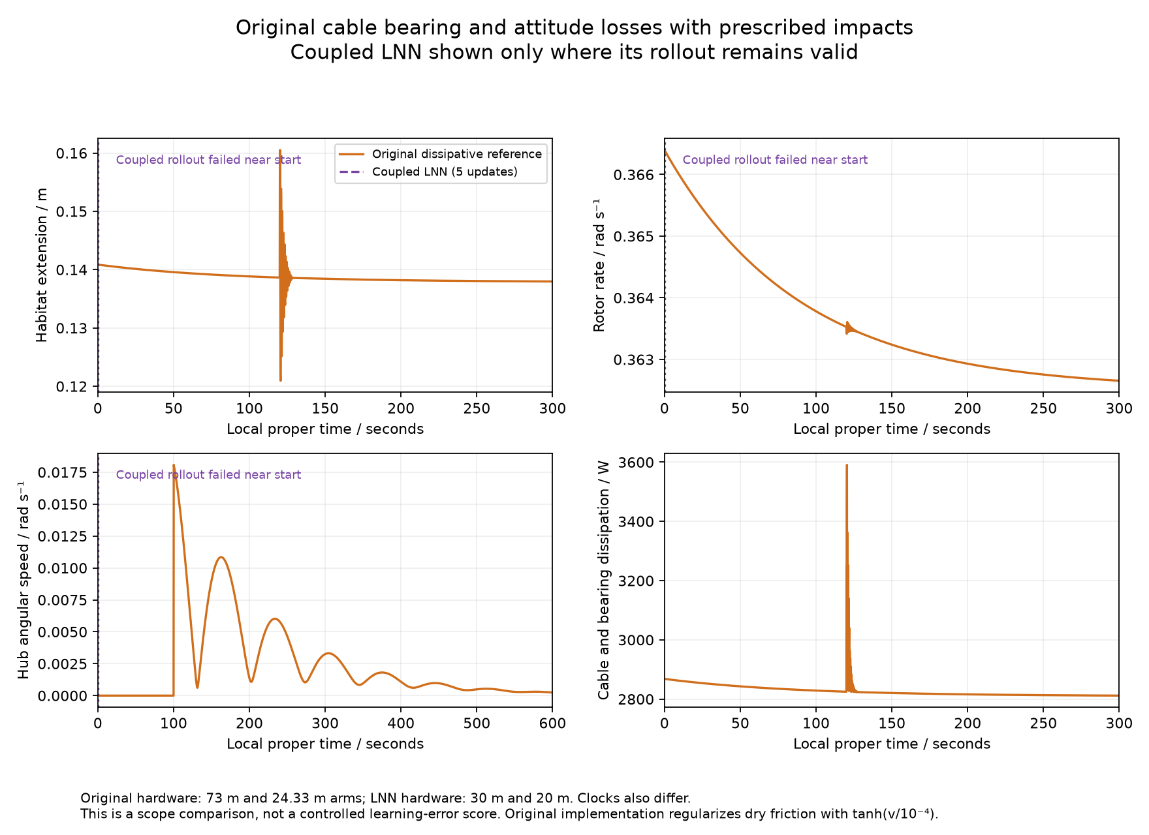
Figure 2 The original reference responds to impacts and loses energy through cables, bearings and attitude damping. The current five-update coupled profile fails near the start; its missing tail is not a prediction. The lower right panel shows cable and bearing power loss. Attitude damping is included in the lower left dynamics, with the original proportional and derivative controller.
Both local internal calculations begin with the original reference extension and spin rate and a nonrotating hub. The saved coupled LNN uses different arm lengths, masses and inertia, and its mathematical clock is coordinate time. The original internal model uses proper time. This figure compares the scope of the two models; it is not a controlled estimate of the coupled network’s learning error. The one-term model has no internal coordinates and cannot predict these quantities.

What the original dissipation function contains
Section 12 of the derivation combines the losses in one Rayleigh dissipation function R. Differentiating R with respect to a coordinate rate gives its resisting force, with a minus sign. Gas and dust use the relativistic drag expression; cables use viscous damping and dry friction; the bearing resists rotor motion; attitude damping resists hub angular velocity.
$$R_{\text{drag}} = (C_{g}ρ_{g} + C_{d}ρ_{d})Ac^{3}(artanh|β| − |β|)$$
$$R_{\text{cables}} = \frac{1}{2}c_{h}{{ξ̇}_{h}}^{2} + \frac{1}{2}c_{c}{{ξ̇}_{c}}^{2} + F_{C h}|{ξ̇}_{h}| + F_{C c}|{ξ̇}_{c}|$$
$$R_{\text{rotation}} = \frac{1}{2}b_{ϑ}{ϑ̇}^{2} + τ_{C}|ϑ̇| + \frac{1}{2}ω^{T}\text{Bω}$$
$$Q_{diss i} = −\frac{∂R}{∂{q̇}_{i}}$$
The gas and dust force is −(Cgρg + Cdρd)Aγ²v|v|. Its mechanical power is negative. Cable viscous losses scale with the square of extension rate. Dry friction has a fixed resisting-force magnitude away from zero rate. Bearing damping and dry friction similarly resist spin. B is the attitude damping matrix; it is separate from the magnetic field symbol used elsewhere in the model.
Original reference parameter | Archived value
Gas and dust densities | 1.67 × 10⁻²¹ and 1 × 10⁻²³ kg/m³; both drag coefficients 1
Cable damping | Damping ratio 0.05; cj = 2ζ√(kjMj)
Cable dry friction | 100 N per radial coordinate
Bearing losses | 20,000 N m s viscous coefficient; 500 N m dry-friction torque
Attitude damping and control | Derivative gain 2,000,000 N m s; proportional gain 500,000 N m
Fuel and thrust | ε = 0.8031; χ = 0.5; thrust magnitude m × 15 m/s²
Original arms and masses | 73 m and 24.333 m; 25,000 kg and 75,000 kg

These values come from the archived companion implementation under hail_mary_physics_complete. They are declared engineering and environmental assumptions, not measurements. The source PDF specifies the equations symbolically. The companion implementation smooths the dry-friction sign near zero with tanh(rate/10⁻⁴); that numerical approximation is disclosed here rather than presented as the exact nonsmooth sign law.
Impacts are momentum jumps, not part of the smooth R function. The archived radial impulse is +5,000 N s at the habitat and −5,000 N s at the counterweight. The angular impulse is (0, 2,000,000, −1,000,000) N m s. Motor and attitude control torques are supplied external inputs.

What these comparisons establish
The new plots include all the original loss categories through their archived nominal and local-transient scenarios. They do not establish one fully coupled relativistic spacecraft: the archived reference integrates travel, centrifuge and attitude in separate partitions. Its hardware also differs from the current coupled learning target. Controlled learning accuracy remains measured against each LNN’s own conservative reference, not inferred from overlaying different physical systems.
Evidence | Present result
Original nominal reference | 13.10551 Earth years; 3.84058 crew years; sampled peak speed 0.9953449c
Original gas and dust energy loss | 8.29173e+15 J over the reference mission
One-term with original external forces | Failed when the predicted path crossed a star; no error score from the missing tail
Coupled profile in original internal comparison | Failed with a nonpositive rotor radius after an accepted prefix of approximately 1.83e-05 seconds
Original force and loss checks | Rayleigh drag derivative and nonpositive loss-power checks passed; independent travel-clock check passed
Full-budget PHM studies | Still pending behind source-control checks; these plots use a 1,000-update trial and a five-update profile

Changing mass and external propulsion make this an open system. A fuel-burning engine can add mechanical energy while drag and damping remove it. Impacts add or remove energy abruptly. A single constant-energy curve is therefore the wrong success test. The plot reports actual drag energy transferred to the medium, while the conservative LNN evaluations separately test true energy change minus supplied work.
The conservative objectives and running code snapshots are unchanged. The new comparison uses the original dissipative reference to explain the extra physics omitted from conservative training. The physical high-speed coupled claim remains gated. A matched original-hardware coupled training study would be a different target and has not been silently substituted for the authorized experiment.

Source records and reproducibility
Read-only references are PHM_Derivations.pdf, sections 7 to 14, and hail_mary_physics_complete/src/hail_mary_model.py with docs/model_specification.md. Their SHA256 hashes and the full original parameter list are saved with the new figure metrics. Original mission, rotor, attitude and neural traces are saved together in reference_and_predictions.npz.
Original Lagrangian Neural Networks paper
Pinned SpecialRelativity notebook
The new evidence is in conservative_training/comparisons/original_derivation_report. This revision replaces the arbitrary-drag illustration in the preceding report version; the earlier version is archived. It is a dated progress report and does not claim completed full training.

